**PROJECT REPORT**

* 1. **Introduction**

**1.1 Overview**

Travel Trax Tours, a tour operator, leverages Zoho Books to manage their bookings, track expenses, and handle invoicing, reconcile payments, and monitor their financial performance. Zoho books helps them streamline their financial operations and enhance customer service.

**1.2 Purpose**

Travel Trax Tours is a fictional company, and “Zoho Books” is an accounting software. In this context, Zoho Books can be used for various financial and accounting purposes for a travel company like TravelTrax Tours. Some common uses would include:

1.Expenses Tracking :

Zoho books help track and categorize expenses related to travel, such as hotel bookings, transportation, meals, and more.

2.Income Tracking:

It can be used to manage revenue generated from tour bookings, ticket sales, and other sources

3.Invoicing :

Travel companies can create and Send professional Invoices to customers for tour packages, making it easier to manage payments.

**2 Problem Definition & Design Thinking**

**2.1 Empathy Map**

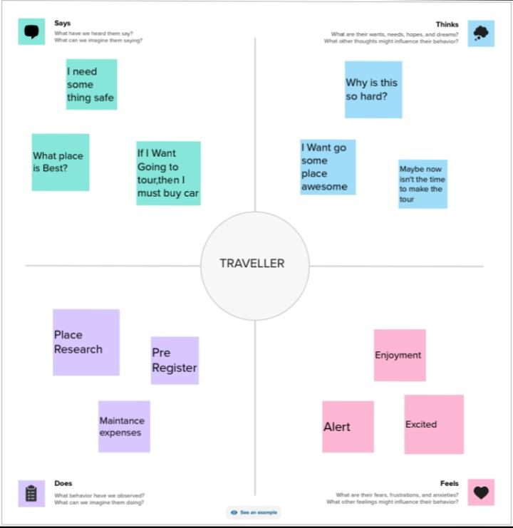

**2.2 Ideation & Brainstorming map**

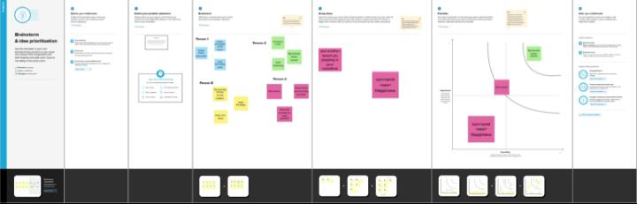

**3 Report :**

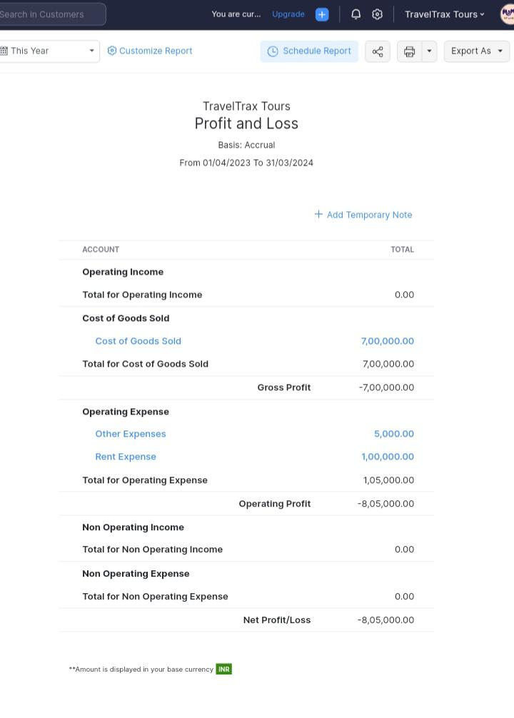

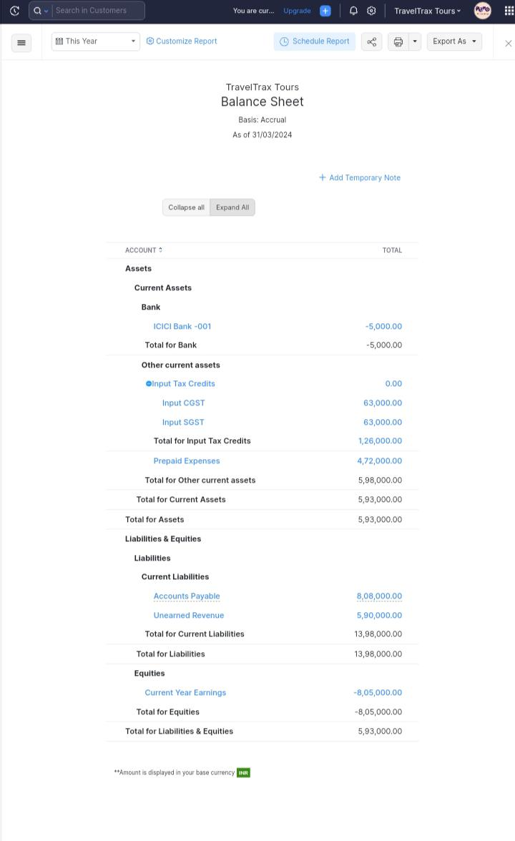

**4 Advantages & Disadvantages**

**Advantages :**

**•** Economic Growth.

**•** The Development of a Country.

**•** Employment Creation.

**•** Unification of Various Societies.

**•** Preservation and Protection

**•** Experience Foreign Culture.

**•** Broaden International Relations.

**Disadvantage:**

**Learning Curve:**

Implementing and learning to use accounting software can be challenging, especially for those unfamiliar with accounting principles.

**Cost**:

Zoho Books, like any software, comes with a subscription cost, which might be an added expense for Travel Trax Tours.

**Customization Limitations:**

While Zoho Books is customizable, it may not meet all of Travel Trax Tours specific needs without some development work.

**Compliance:**

Travel companies often have complex Books complies with these may require additional effort.

**Application :**

Development of Travel and Tourism applications is made easy for travelers for planning tour, ticket booking, booking accommodation, route mapping, cab booking and many more. CAFSInfotech lists some of the basic uses of mobile applications for the travel and tourism industry

**Conclusion :**

In conclusion, travel and tourism have significantly shaped the global economy and brought people together from different cultures and backgrounds. The industry has shown remarkable resilience in the face of various challenges, such as the COVID-19 pandemic, and has continued to grow and evolve. UK English, as the official language of the United Kingdom, has proven to be a valuable asset for the tourism industry, making it easier for international visitors to understand and navigate their way around the country. Moreover, UK English is widely used in the travel and tourism industry, serving as a lingua franca for employees and customers from different countries.

**Futures Scope :**

Candidates looking to pursue their career in the industry can choose to work for travel agencies, government tourism departments, tour operations, immigration and customs services, airlines, hotels, and the list continues.

1. Tourism is an amalgam of phenomenon and relationships rather than a single one.

2. This phenomena and relationships arise from a movement of people to, and a stay in, various destinations; there is a dynamic element (the journey) a static element (the stay)

.3. The journey and stay are to and in destination outside the normal place of residence and work, so that tourism arises to activities which are distinct from those of the resident and working populations of the places of the places through which tourists travel and of their destinations.

4. The movement to the destinations is of a temporary, short term character.

5. Destinations are visited for purposes not connected to paid work – that is, not to take up employment.